You can get free English OCR software at http://www.simpleocr.com/ or upload image online for OCR at http://www.free-ocr.com/ and the reviews of free OCR at http://www.makeuseof.com/tag/top-5-free-ocr-software-tools-to-convert-your-images-into-text-nb/

For other languages, such as Chinese or Russian, download 30-day trial of Adobe Acrobat Pro X from http://www.adobe.com
- Install and launch Adobe Acrobat Pro
- Select Combine Files in PDF
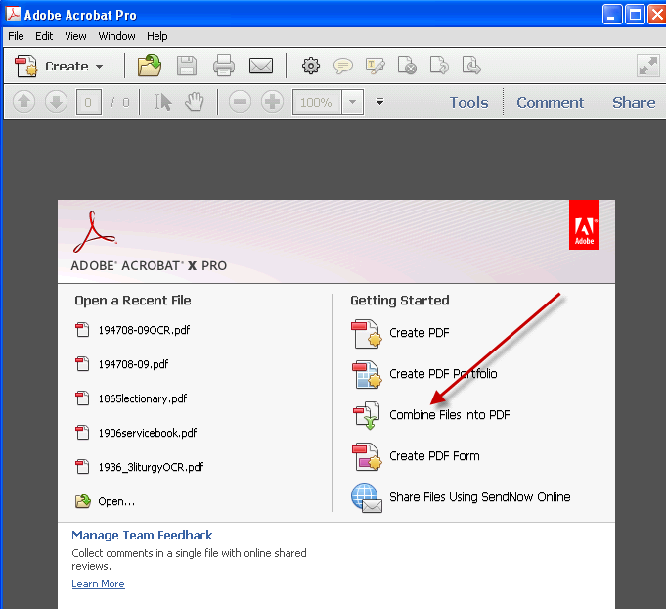
- Drag and Drop image files and click Combine Files
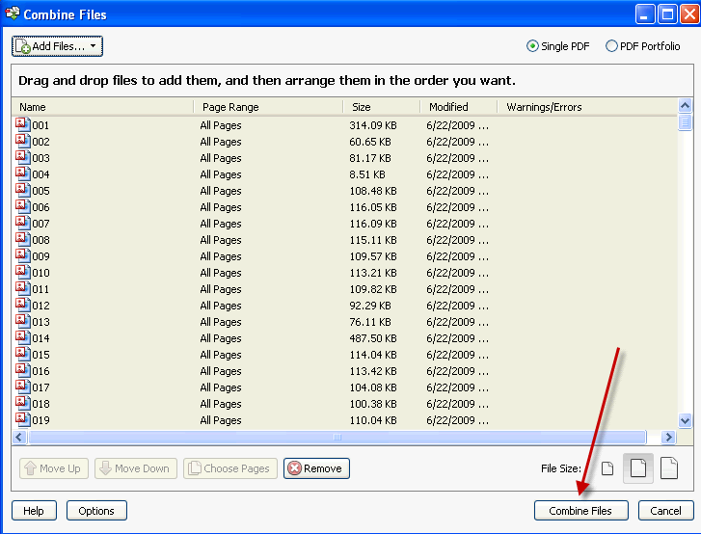
- After PDF is created, click View > Tools > Recognize Text
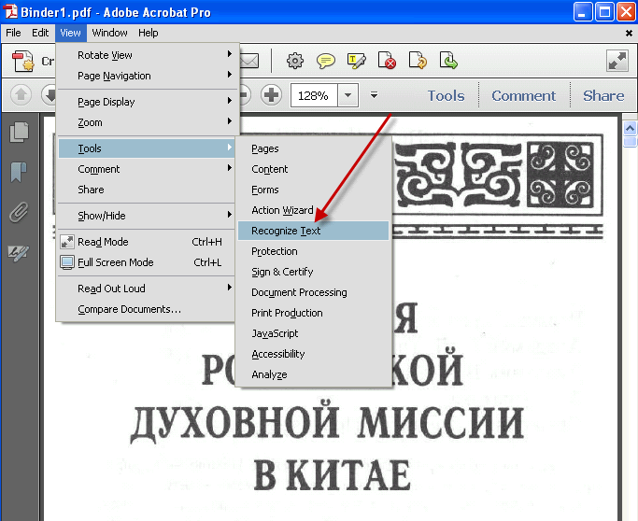
- On right pane, under Recognize Text, select In This File
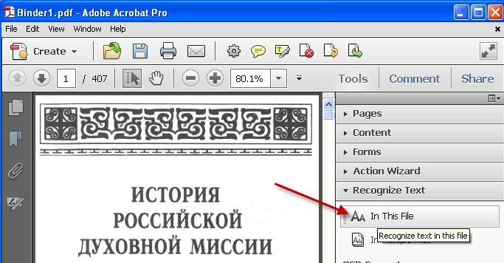
- Select All Pages, and click Edit if Primary OCR language is not correct.
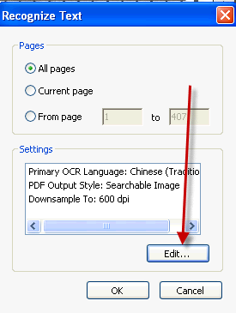
- Select correct language from dropdown
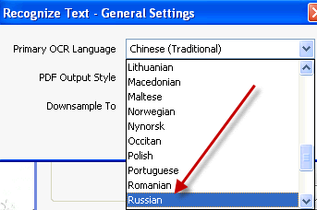
- Click OK
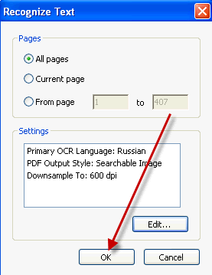
- After OCR is completed, click File > Save As… and select PDF…
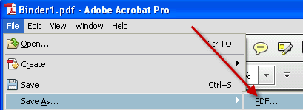
- Provide name and click Save
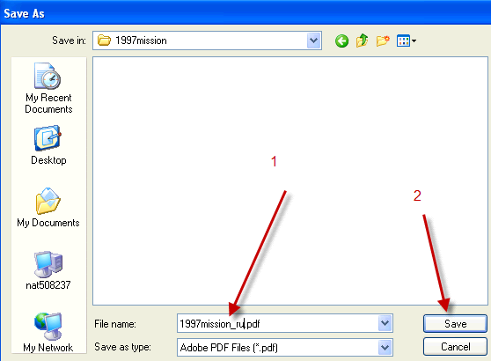
- Save to text by clicking File > Save As… > More Options > Text (Plain)
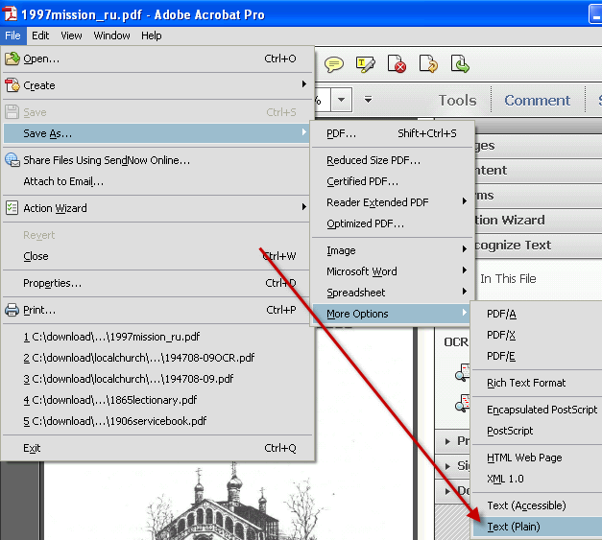
- Click Settings…
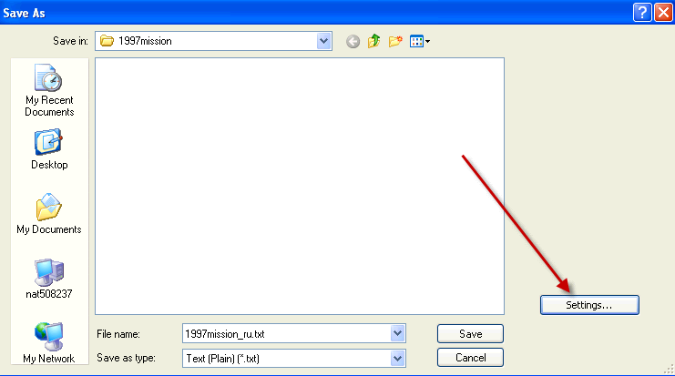
- Set Encoding: UTF-8 and click OK
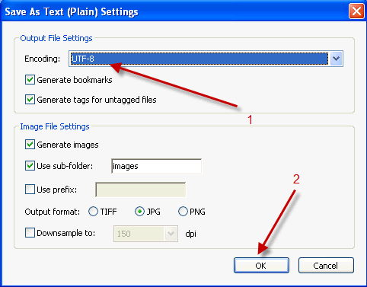
- Provide file name and click Save
