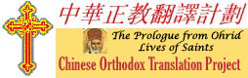
5th Saturday after Pentecost
Partially funded by the Order of St Ignatius of Antioch
July 23, 2005
Partially funded by the Order of St Ignatius of Antioch

FOR IMMEDIATE RELEASE
For more information about the Chinese Orthodox Translation Project, see http://prologue.orthodox.cn or contact Project Coordinator, Nelson Mitrophan Chin at mitrophan@orthodox.cn
Unicode Support for Menologion 3.0 coming soon
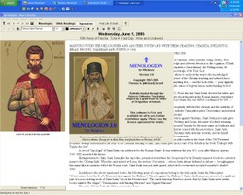
The Chinese Orthodox Translation Project has set up a web page at http://orthodox.cn/software/ to coordinate development and multilingual translation efforts for the next generation of the MENOLOGION 3.0, a free computer program which provides an easy way to access the Troparia, Kontakia, Bible Readings and Lives of Saints of the day.
The alpha test version of the MENOLOGION 3.0 has incorporated a couple of new key features already:

- Display daily readings from the Lives of Saints as translated into English from the original Russian by Fr Stephen Janos.
- Display user choice of Bible versions for daily lectionary reading, including the ability to import Bible modules from http://unbound.biola.edu
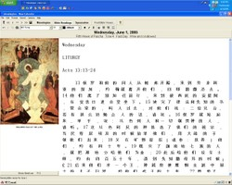
Development for Unicode support for multilingual capability and importing of the Chinese translation of the Prologue from Ohrid and the Troparia/Kontakia hymns will be forthcoming.
If you are interested in participating in our beta testing program or to localize the Menologion into your particular language, please contact the author at michael.purcell@mindspring.com.

Enthusiastic response has already been received from volunteers to localize the Menologion into Romanian and French. You will also need to use a localization tool called poEdit, downloadable from poedit.org .

