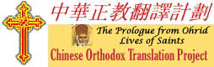
30th Sunday after Pentecost
December 19, 2010

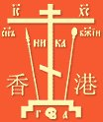
FOR IMMEDIATE RELEASE
Order of St Ignatius awards $3000 grant renewal for continued Chinese Translation of Lives of Saints
The Order of St Ignatius of Antioch, at its governing council meeting held in Jacksonville, Florida on October 22, 2010, approved a $3,000 grant renewal to the Orthodox Fellowship of All Saints of China.

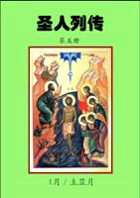
This grant comes with the archpastoral blessing of Metropolitan PHILIP at a critical juncture after the inaugural publication of the Chinese translation of the January volume of the Prologue from Ohrid by St Nikolai of Zica supplemented with additional lives of selected saints from other synaxaria.
Partially funded by The Order of St Ignatius of Antioch

The grant will make possible the uninterrupted translation and publication of subsequent monthly volumes of this invaluable work for the daily spiritual nourishment of the Chinese speaking Faithful and inquirers into the Faith from other confessions, in and outside of China

As a supplement to the grant, consider sponsoring for a specific daily reading of the Prologue from Ohrid, for the good health or in memory of loved one, for a names day, wedding anniversary, day of repose, or any other special occasion, which will be noted on the bottom of each sponsored entry of the Prologue, and those reading the daily devotion for that day can pray for your loved ones. Check feast day available for sponsorship at http://prologue.orthodox.cn/prayers.html
For more information about the Chinese Orthodox Translation Project or other initiatives of the Orthodox Fellowship of All Saints of China, contact Nelson Mitrophan Chin at mitrophan@orthodox.cn or Fr Dionisy Pozdnyaev of the Orthodox Brotherhood of Saints Apostles Peter & Paul in Hong Kong at church@orthodoxy.hk
For more information about The Order of St Ignatius of Antioch, contact Joanne B. Hakim at TheOrder@antiochian.org

