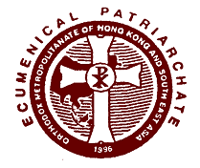
ECUMENICAL PATRIARCHATE
ORTHODOX METROPOLITANATE OF HONG KONG
AND SOUTH EAST ASIA

PRESS RELEASE

The Holy and Sacred Synod of the Ecumenical Patriarchate, during its meeting today under the presidency of His All Holiness Ecumenical Patriarch Bartholomew, elected Very Reverend Archimandrite Nektarios Tsilis, who was, until today, the Episcopal Vicar of the Metropolis of Samos, the new Metropolitan of Hong Kong and South East Asia.

The ordination of the newly elected Metropolitan will take place in the Phanar at the Patriarchal church of St. George in Constantinople, on Sunday, January 20th, 2008.

Hong Kong, January 9th 2008

From the Office of
ORTHODOX METROPOLITANATE OF HONG KONG
AND SOUTH EAST ASIA

#704 UNIVERSAL TRADE CENTER 3 ARBUTHNOT RD HONG KONG
TEL: +852 25738328 FAX +852 25738379
office@omhksea.org
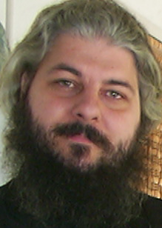

Biographical Notes

The Very Reverend Archimandrite Nektarios Tsilis was born in 1969 in Dodoni, Ioannina, Greece.

He is a graduate of Theological Academy in Athens and the Theological School of the University of Athens. He has also successfully completed courses and seminars on the structure, organization, and information technologies of the European Union.

He was ordained deacon in 1990 and priest in 1995.

He served as a deacon throughout 1990-1995 in the parishes of the Annunciation of Theotokos, the Holy Unmercenaries, and Saint Sophia, in the Metropolis of Piraeus.

He served as a priest throughout 1995-2001 in the capacity of preacher of the Holy Metropolis of Piraeus, Proistamenos of the parish of the Life-Giving Fountain, Secretary of the Metropolis’ Youth Organization, and as President of the committee of the Church of Hatzikyriakou Orphanage. He was the Director of the program “Peiraiki Ecclesia 91.2FM” as well as the Deputy Manager of the magazine “Peiraiki Ecclesia”.

From 2001 to the present he has served as the Vicar of the Holy Metropolis of Samos and Ikaria, member of the Spiritual Court, Proistamenos of the Cathedral of St. Nicholas in Samos, Chairman of the Board of Panagia Spyliani, and Abbot of the Panagia Vrodiani Monastery.

He has participated, as a representative of the Metropolises of Piraeus and Samos, in youth conferences, seminars on cults and new religious movements, and issues concerning Europe’s stance on religion.

He is a regular contributor to many magazines and periodicals.
He is fluent in Greek and English.

